MAC & SCALE Microarchitecture

High-Level Overview
The MAC & SCALE module is the primary arithmetic datapath of the PE. It receives two 32-bit operands and computes multiply-accumulate and scaling operations under the direct, cycle-by-cycle control of the PE Controller.
The datapath is organized into three blocks: Input Routing, Compute Core, and Accumulation Unit.

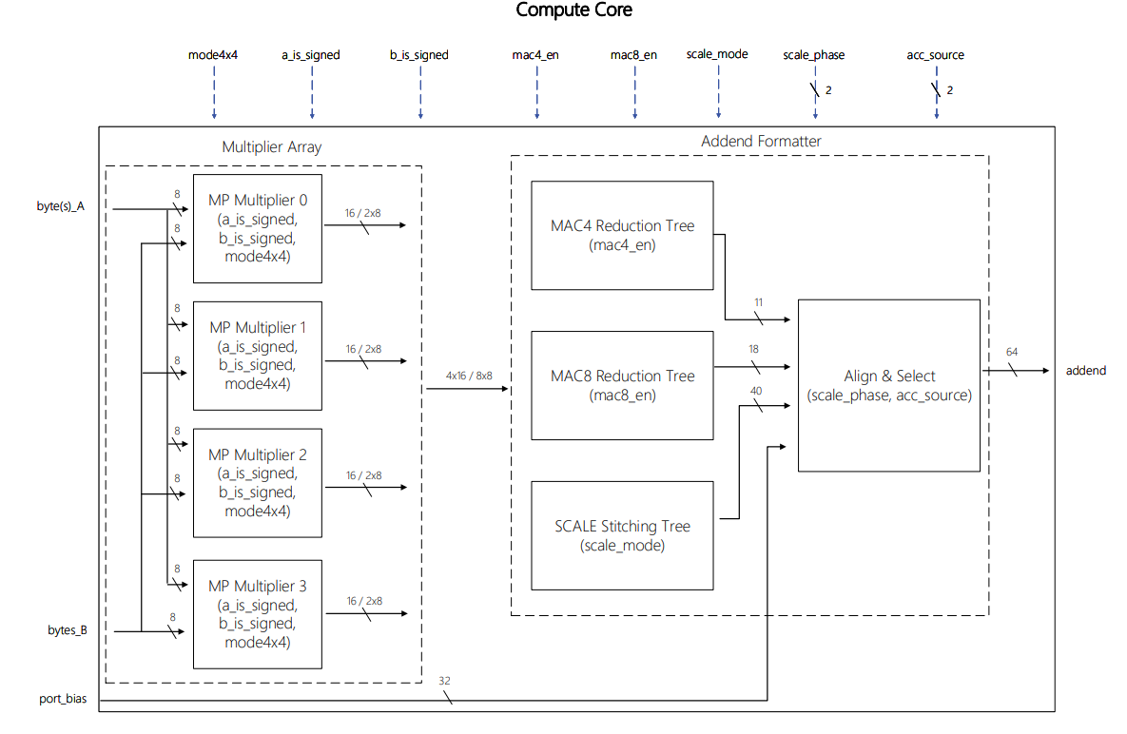
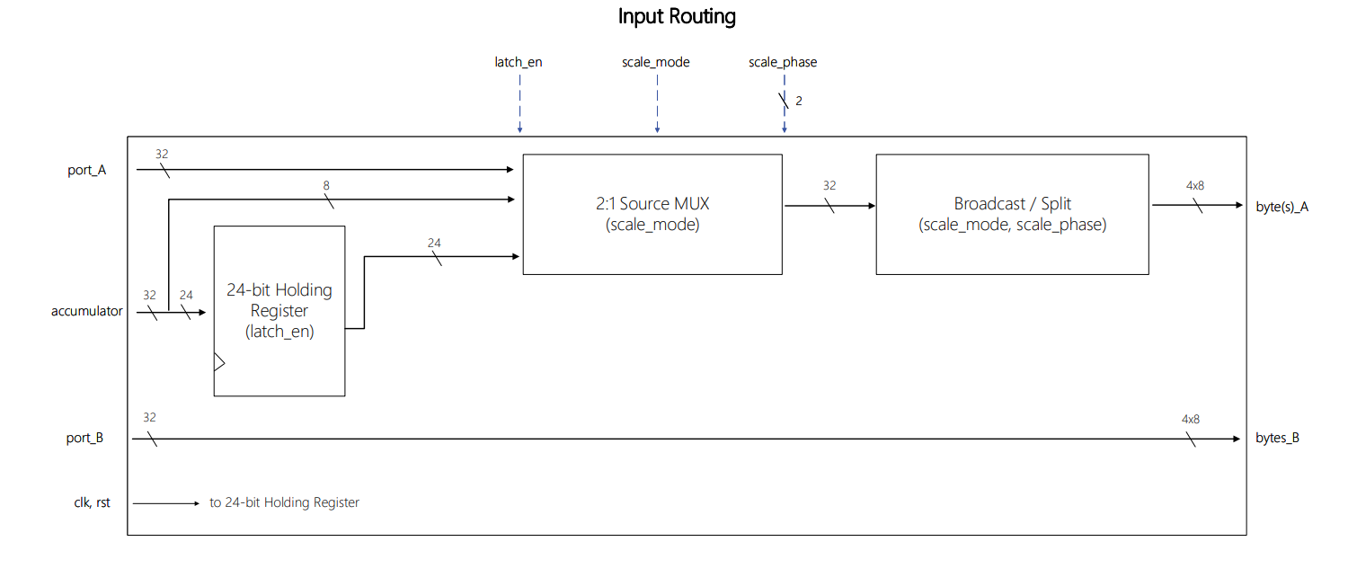
Block Diagram

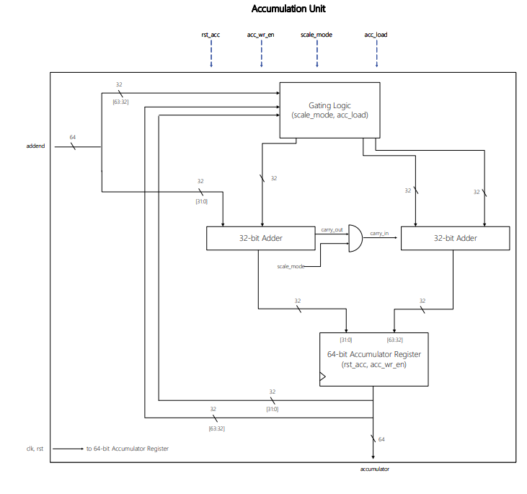
Figure 1. Block-level microarchitecture.

Interface
Data Ports
Port Name | Direction | Width | Description
clk | Input | 1 bit | Main system clock. The accumulator and holding registers capture their inputs on the positive edge.
rst | Input | 1 bit | Active-low asynchronous reset. Clears the accumulator and holding register to zero.
port_A | Input | 32-bit bus | First data operand. In MAC mode, it carries four signed INT8 values or eight signed INT4 values packed into 32 bits, depending on the active precision mode.  During all other commands, port_A is not consumed by the datapath.
port_B | Input | 32-bit bus | Second data operand. In MAC mode, it carries packed signed integers, matching port_A. In SCALE mode, it carries a 32-bit unsigned scaling factor. In ADD_BIAS mode, it carries a 32-bit signed bias value.
accumulator | Output | 64-bit bus | The internal accumulator register value. During MAC and ADD_BIAS, only the lower 32 bits are written; the upper 32 bits retain their last-written value (zero after reset, or the upper half of the most recent SCALE result). At the end of the last SCALE cycle, the full 64 bits hold the scaled result. This bus feeds the downstream Post-Processing Unit.
Table 1. Data port interface.

Control Ports
Port Name | Direction | Width | Description
mode4x4 | Input | 1 bit | Multiplier array mode select. When high, the four MP_Multipliers operate as eight independent 4×4 multipliers. When low, they operate as four 8×8 multipliers.
a_is_signed | Input | 1 bit | Sign control flag for all port_A bytes entering the multiplier array. During MAC operations, this is high (signed). During SCALE cycles 0–2, this is low (unsigned magnitude). During SCALE cycle 3, this is high (sign byte).
b_is_signed | Input | 1 bit | Sign control flag for all port_B bytes entering the multiplier array. During MAC operations, this is high (signed). During SCALE, this is low (unsigned scaling factor).
scale_mode | Input | 1 bit | Serves two purposes:  1. SCALE datapath mode enable. When high, the Source Mux selects {holding_reg[23:0], acc[7:0]}) and the Broadcast/Split block broadcasts a single byte to all four multipliers. When low, the Source Mux selects port_A and the Broadcast/Split block routes four individual bytes to their respective multipliers.  2. Operand isolation enable for the SCALE stitching tree. When low, the four 16-bit products inputs to this tree are forced to zero.
latch_en | Input | 1 bit | Holding register capture enable. When high, accumulator[31:8] is latched into the 24-bit holding register on the next rising clock edge.
scale_phase | Input | 2-bit bus | SCALE cycle index (0–3). When scale_mode is high, selects which accumulator byte is broadcast to the multiplier array. Simultaneously controls how many bit positions the 40-bit stitching tree output is shifted left:  0 (0), 8 (1), 16 (2), or 24 (3).  Ignored during single-cycle commands.
mac4_en | Input | 1 bit | Enable for the MAC4 reduction path. When high, the MAC4 path is active and the MAC8 / SCALE inputs are forced to zero; when low, the MAC4 reduction tree inputs are forced to zero.
mac8_en | Input | 1 bit | Enable for the MAC8 reduction path. When high, the MAC8 path is active and the MAC4 / SCALE inputs are forced to zero; when low, the MAC8 reduction tree inputs are forced to zero.
acc_source | Input | 2-bit bus | Accumulator input source select. Determines what value is added to the accumulator on the current cycle: MAC4 product sum (0), MAC8 product sum (1), SCALE shifted partial product (2), or bias from port_B (3).
acc_wr_en | Input | 1 bit | Accumulator write enable. When high, the accumulator register captures the adder output on the next clock rising edge.  During MAC and ADD_BIAS operations, only the lower 32-bit register is enabled. During SCALE, the full 64-bit register is enabled.  When low, the register holds its current value.
acc_load | Input | 1 bit | Accumulator direct load. When high, the accumulator feedback to both adders is forced to zero. The Controller asserts this signal on SCALE cycle 0 to overwrite the accumulator with the first partial product.
rst_acc | Input | 1 bit | Synchronous accumulator clear. When high, the accumulator register is reset to zero on the next clock edge.
Table 2. Control port interface.
Input Routing
The Input Routing block sits between the external Input Register Bank of the PE and the Compute Core. It selects, splits, and distributes the correct byte-level operands to each of the four multipliers.
The routing to the byte(s)_A port is supported by two modes. When scale_mode is low, during MAC operations, the 32-bit port_A is split into four 8-bit bytes (byteA0 through byteA3), each routed to its respective multiplier. When scale_mode is high, during SCALE, a single byte is broadcast to all four multipliers. The broadcast byte is selected by scale_phase: On cycle 0 (scale_phase = 0), the byte is sourced directly from the 8-least significant bits of the accumulator (accumulator[7:0]). On cycles 1–3, scale_phase selects the appropriate byte from the holding register.
The holding register captures accumulator[31:8] when latch_en is asserted. This occurs on the first SCALE cycle (cycle 0), preserving the upper three bytes of the pre-SCALE lower 32-bit accumulator (accumulator[31:8]), before the accumulator is overwritten with the first partial product. The lowest byte does not require latching: on cycle 0, it is consumed directly from the accumulator output before it is overwritten. That register is cleared asynchronously to zero by the active-low rst signal.
The bytes_B port is fed with port_B four 8-bit bytes, each routed to its respective multiplier, in each one of the modes mentioned above.

Compute Core
The Compute Core contains the multiplier array and the addend formatter. It is described below as two sub-blocks.
Multiplier Array
The Multiplier Array multiplies byte-level operands, producing the partial products consumed by the Addend Formatter. It is implemented as four MP_Multiplier instances operating in parallel.
The array receives its operands from the Input Routing block and its control signals from the Controller: mode4x4 sets the precision mode, a_is_signed controls the sign treatment of byte(s)_A and b_is_signed controls the sign treatment of bytes_B.
In MAC 8×8 (mode4x4 low) or in SCALE operations, the Multiplier Array multiplies each byte from byte(s)_A bus with its corresponding byte from byte_B bus and concatenates the four 16-bit results onto its output bus.
In MAC 4×4 (mode4x4 high) it multiplies each half-byte from byte(s)_A bus with its corresponding half-byte from byte_B bus and concatenates the eight 8-bit results onto its output bus.
a_is_signed controls the sign treatment of the bytes/half-bytes from the byte(s)_A bus, and b_is_signed controls the sign treatment of those from the byte_B bus.
Addend Formatter
The Addend Formatter takes the multiplier products and produces a 32/64-bit (based on acc_source) addend for the Accumulation Unit. It contains three adder trees, and the Align & Select unit.
MAC4 Reduction Tree. When mac4_en is high, the MAC4 reduction tree sums the eight signed products produced by the multiplier array and forwards the 11-bit result to the Align & Select unit.
MAC8 Reduction Tree. When mac8_en is high, the MAC8 reduction tree sums the four signed products produced by the multiplier array and forwards the 18-bit result to the Align & Select unit.

SCALE Stitching Tree. When scale_mode is high, the stitching tree reconstructs a single 8×32 partial product from the four 16-bit multiplier outputs by combining them at their correct bit-position offsets. The tree has two stages. In the first stage, two 24-bit adders combine adjacent byte-pairs: the first adder sums byteA0's product with byteA1's product shifted left by 8 bits; the second adder does the same for byteA2 and byteA3. The extension applied to each product before addition is controlled by the a_is_signed flag: when low (cycles 0–2), the products are zero-padded; when high (cycle 3), the products are sign-extended. In the final stage, a 40-bit adder combines the two 24-bit results, with the upper pair shifted left by 16 bits, producing a single 40-bit partial product. This 40-bit value is passed to the Align & Select unit.
Align & Select. This unit receives four inputs: the 11-bit MAC4 result and the 18-bit MAC8 result from the MAC Reduction Tree, the 40-bit partial product from the SCALE Stitching Tree, and the 32-bit port_B bus. The MAC4 and MAC8 paths are sign-extended to 32 bits. The port_B path passes through its 32-bit width. The SCALE path shifts the 40-bit input left by 0, 8, 16, or 24 bit positions according to scale_phase. On cycles 0–2 the shifted result is zero-padded to 64 bits, and on cycle 3 it populates the full 64-bit width. A 4:1 multiplexer controlled by acc_source selects the active addend for the lower 32 bits: MAC4 product sum (0), MAC8 product sum (1), SCALE shifted partial product (2), or bias from port_B (3). The upper 32 bits of the addend carry the upper portion of the SCALE shifted result; during MAC and ADD_BIAS operations these bits are undefined. The selected addend is routed to the Accumulation Unit.

Accumulation Unit
The Accumulation Unit contains Gating Logic, two 32-bit adders, and the 64-bit accumulator register.
Each adder receives two inputs: an addend half from the Compute Core and an accumulator feedback half. The Accumulation Unit adds its 64-bit input bus to the accumulator and stores the result in the accumulator.
The Gating Logic controls three of the four inputs to the adders: outside of SCALE, both inputs to the upper 32-bit adder, including its carry-in, are forced to zero. When the accumulator is being loaded, the lower feedback half is also forced to zero.
During MAC and ADD_BIAS, the addition affects only the lower 32 bits of the accumulator. During SCALE, the full 64-bit accumulator is updated each cycle: cycle 0 loads the first partial product; cycles 1–3 add subsequent shifted partial products into the running result.
Accumulator Register
The 64-bit register captures its input on the next rising clock edge when acc_wr_en is high. The upper 32-bit half also additionally requires scale_mode to be high.
During MAC and ADD_BIAS operations, only the lower 32-bit register is loaded. During SCALE, the full 64-bit register is loaded. When acc_wr_en is low, the register holds its current value.
The register supports two reset paths. The asynchronous hardware reset (rst) immediately clears the register to zero regardless of the clock. The synchronous software clear (rst_acc) flushes the register to zero on the next rising clock edge, allowing the Controller to prepare the accumulator for a new computation without asserting the global reset.

